2303A51581
Batch-10
LAB ASSIGNMENT-6.4
Task 1: Student Performance Evaluation System
#PROMPT
Create a method to display student details using self attributes. Create another method to check if student marks are above class average using if-else and return a message.
#CODE
class Student:
def __init__(self, name, roll_number, marks):
self.name = name
self.roll_number = roll_number
self.marks = marks

def display_details(self):
print("Student Name:", self.name)
print("Roll Number:", self.roll_number)
print("Marks:", self.marks)

def check_performance(self, class_average):
if self.marks > class_average:
return "Performance Status: Above Class Average"
else:
return "Performance Status: Below Class Average"
# User Input
name = input("Enter student name: ")
roll_number = input("Enter roll number: ")
marks = float(input("Enter student marks: "))
class_average = float(input("Enter class average marks: "))
# Object Creation
student = Student(name, roll_number, marks)
# Output
print("\n--- Student Details ---")
student.display_details()
print(student.check_performance(class_average))
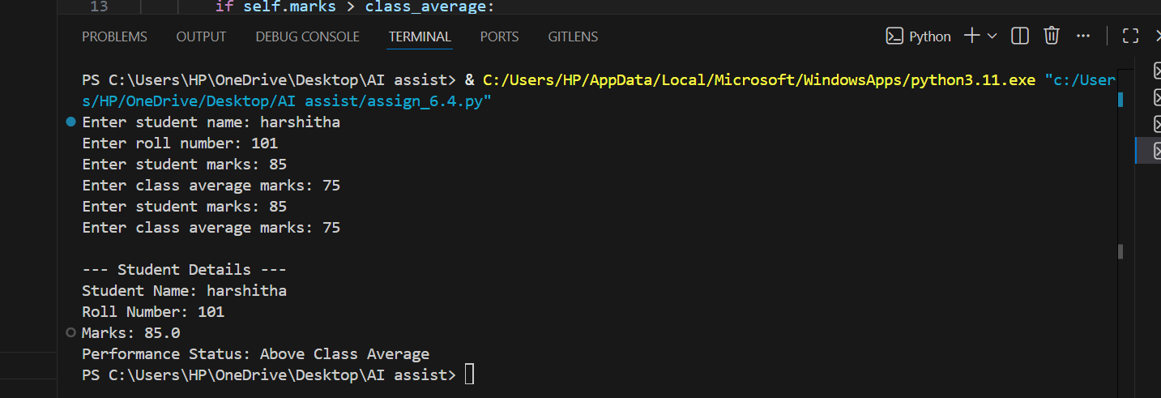
#OUTPUT
ANALYSIS
This program uses a Student class to store student details like name, roll number, and marks. It takes input from the user to make the program interactive and uses the __init__ constructor to initialize values with self. The display_ details () method prints the student’s information, and the check_ performance () method uses an if-else condition to compare the student’s marks with the class average and return a performance message.
Task 2: Data Processing in a Monitoring System
#PROMPT
Use % operator to check even numbers using for loop iterative. If even, find square and print in readable format.
#CODE
# Take sensor readings from user
n = int(input("Enter number of sensor readings: "))
readings = []
for i in range(n):
value = int(input(f"Enter reading {i+1}: "))
readings.append(value)
# Copilot: loop through the readings list
for r in readings:
# Copilot: check if the number is even using modulus
# Copilot: if even, calculate its square
# Copilot: print result like "Even Reading: 10, Square: 100"
if r % 2 == 0:
square = r * r
print(f"Even Reading: {r}, Square: {square}")
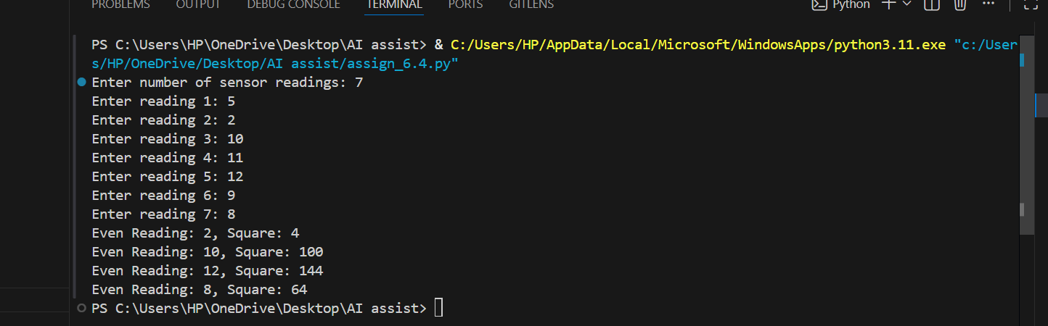
#OUTPUT
#ANALYSIS
This program processes a list of sensor readings using a for loop. It uses the modulus operator to check whether a number is even or not and then calculates the square if it is even values. The if-else logic executes only even readings and printed in a clear format.
Task 3: Banking Transaction Simulation
#PROMPT
Create a method to deposit money and withdraw money by adding amount to self.balance and using if-else and print updated balance. If amount is less than or equal to balance, deduct and print remaining balance. If amount is greater than balance, print a "Insufficient balance" message.

#CODE
class BankAccount:
def __init__(self, account_holder, balance):
self.account_holder = account_holder
self.balance = balance

# Deposit money into the account
def deposit(self, amount):
self.balance += amount
print(f"Deposit Successful! New Balance: {self.balance}")
# Withdraw money from the account
def withdraw(self, amount):
if amount <= self.balance:
self.balance -= amount
print(f"Withdrawal Successful! Remaining Balance: {self.balance}")
else:
print("Insufficient Balance! Withdrawal Failed.")

# Display account details
def display_details(self):
print("Account Holder:", self.account_holder)
print("Current Balance:", self.balance)
# Sample Usage with User Input
if __name__ == "__main__":
name = input("Enter account holder name: ")
balance = float(input("Enter initial balance: "))

account = BankAccount(name, balance)

print("\n--- Account Details ---")
account.display_details()

print("\nChoose Transaction")
print("1. Deposit")
print("2. Withdraw")
choice = int(input("Enter your choice: "))
amount = float(input("Enter amount: "))

if choice == 1:
account.deposit(amount)
elif choice == 2:
account.withdraw(amount)
else:
print("Invalid choice")
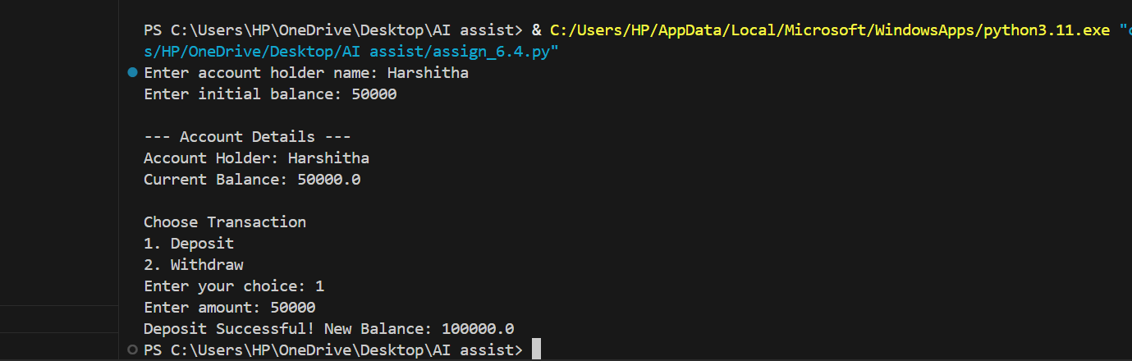
#OUTPUT
#ANALYSIS
This program uses a Bank Account class to perform basic banking operations like deposit and withdrawal. It takes user input for the account holder’s name and balance, then allows the user to choose a transaction type. The deposit and withdraw methods use self to update the balance, and an if-else condition ensures withdrawals are only allowed when sufficient funds are available.
Task 4: Student Scholarship Eligibility Check
#PROMPT
Use a while loop with an index to go through the students list. Check if the score is greater than 75. If true, print "ELIGIBLE", else print "NOT ELIGIBLE". Make the output readable with the student name and score.
#CODE
students = []
num_students = int(input("Enter the number of students: "))
for i in range(num_students):
name = input(f"Enter name of student {i + 1}: ")
score = float(input(f"Enter score of student {i + 1}: "))
students.append((name, score))

print("\n--- Student Eligibility ---")

index = 0
while index < len(students):
name, score = students[index]
if score > 75:
print(f"{name} is ELIGIBLE with a score of {score}.")
else:
print(f"{name} is NOT ELIGIBLE with a score of {score}.")
index += 1
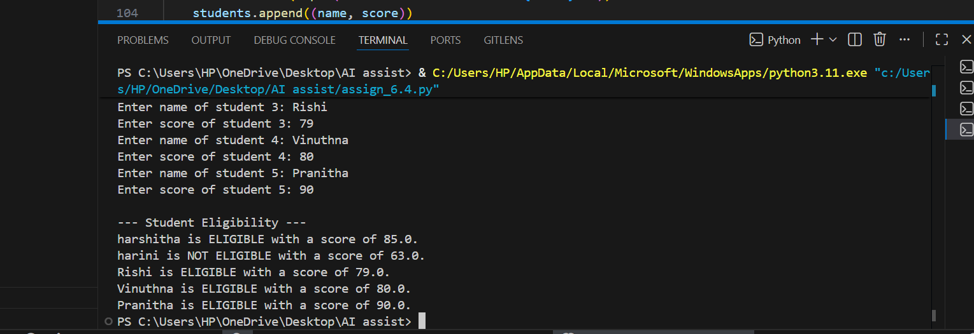
#OUTPUT
#ANALYSIS
This program takes student names and scores as user input and stores them in a list. A while loop is used to iterate through the list using an index variable. The if-else condition checks whether each student’s score is greater than 75 and prints whether the student is eligible or not in a clear, readable format.
Task 5: Online Shopping Cart Module
#PROMPT
Create a Shopping Cart class with a dictionary to store items. Generate methods to add and remove items using loops and if-else. Create a method to calculate total using a loop (price * quantity). Apply a discount using if-else if total exceeds a limit or if a valid rate is given. Print results in a clean and readable format.
#CODE
class ShoppingCart:
def __init__(self):
self.items = {}
def add_item(self, item_name, price, quantity):
if item_name in self.items:
self.items[item_name]['quantity'] += quantity
else:
self.items[item_name] = {'price': price, 'quantity': quantity}
print(f"Added {quantity} of {item_name} to cart.")

def remove_item(self, item_name, quantity):
if item_name in self.items:
if quantity >= self.items[item_name]['quantity']:
del self.items[item_name]
print(f"Removed all of {item_name} from cart.")
else:
self.items[item_name]['quantity'] -= quantity
print(f"Removed {quantity} of {item_name} from cart.")
else:
print(f"{item_name} not found in cart.")

def calculate_total(self):
total = 0
for item in self.items.values():
total += item['price'] * item['quantity']
return total

def apply_discount(self, discount_rate):
total = self.calculate_total()

# Apply discount only if rate is between 0 and 1
if 0 < discount_rate < 1:
discount_amount = total * discount_rate
total_after_discount = total - discount_amount
print(f"Discount Applied: ${discount_amount:.2f}")
return total_after_discount
else:
print("Invalid discount rate. No discount applied.")
return total
# Example usage
if __name__ == "__main__":
cart = ShoppingCart()

cart.add_item("Apple", 0.5, 10)
cart.add_item("Banana", 0.3, 5)
cart.add_item("Orange", 0.8, 8)

print(f"\nTotal before discount: ${cart.calculate_total():.2f}")

total_after_discount = cart.apply_discount(0.10) # 10% discount
print(f"Total after discount: ${total_after_discount:.2f}")

cart.remove_item("Banana", 2)
print(f"Total after removing items: ${cart.calculate_total():.2f}")
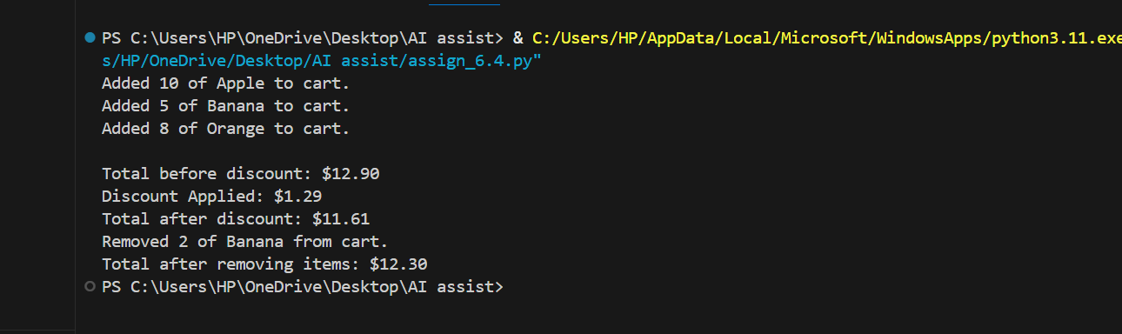
#OUTPUT
#ANALYSIS
This program uses a Shopping Cart class to manage items in a cart using a dictionary. Copilot generates methods for adding, removing, and calculating the total with loops and if-else conditions. A discount is applied based on a condition, and the program prints user-friendly messages showing the cart total and final bill clearly.

